2017 Job Opportunities for Blind Students (JOBS)
Summer Work Program
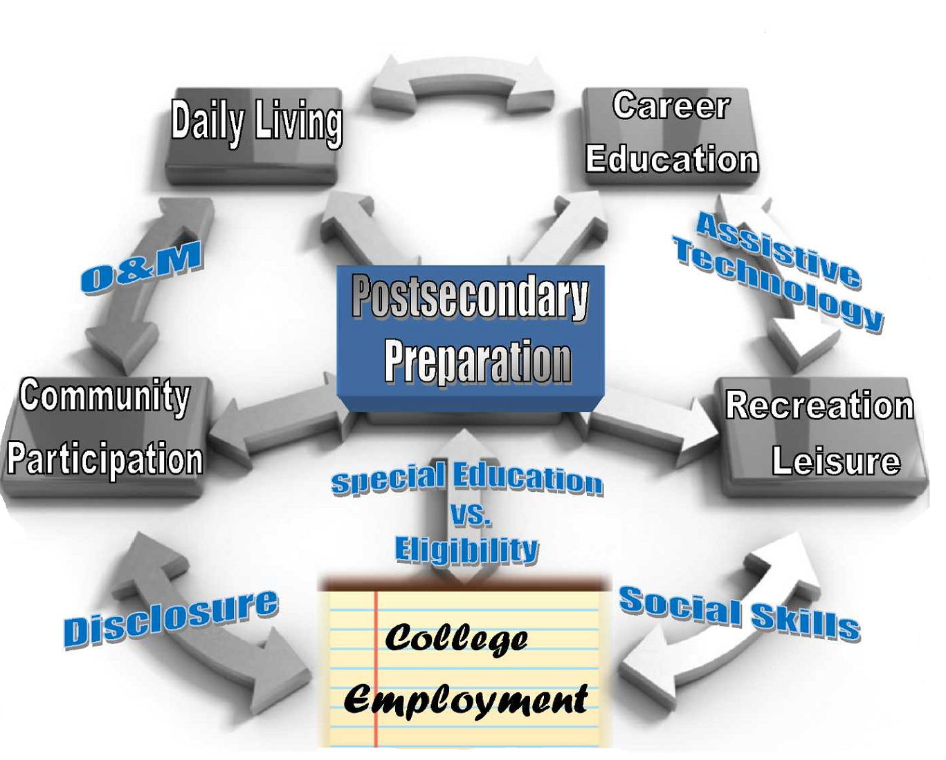
Who: DARS students enrolled in a Region 13 school district between the ages of 15 and 19 years old.
When: June 11 - June 30, 2017
Where: Hardin House Apartments and UT campus
***Application Due Date: 2/19/17***

2017 JOBS Summer Work Program
General Eligibility factors:
Students functioning within 2 years of academic grade level
Ages 15 – 19 and have not graduated from high school
Students ages 16 and over will have priority during selection process

Medical
The program is not equipped to handle medical conditions that require monitoring by a nurse or medically trained staff. Students with medical issues that require adult administration of medications and/or monitoring to ensure scheduled and proper dosage may not be accepted into the program.

Program Components
Work Readiness:
- interviewing skills
- completing applications
- interest inventory
- work values
- career exploration and search
- college criteria and admission process
- living and transportation options

Develop an Ability statement: an organized document that a person with a disability develops to assist them during an interview

Familiarization to terms:
- eligibility
- access to services
- rights as a person with a disability and how these differ from youth to adulthood.

Work Experience: Participants will experience a two week paid employment in community worksites

Daily Living Skills:
- Appropriate dress/grooming/hygiene
- Maintaining apartment (making bed, vacuuming, sweeping, washing dishes, cleaning microwave/stove/counters)
- Meal planning and preparation
- Grocery shopping and storage
- Laundry
- Time management (morning routine, classes, travel, evening activities)
- Money management (organization, budgeting, making purchases)

O&M: learning how to travel safely within a community including cane travel (accessing the workplace and utilizing public transportation)

Assistive Technology:
- note-taking
- creating and retrieving documents (tablet, smart phone, computer)
- low vision devices (magnifier, monocular)
(It is not a requirement that the student have any of the devices listed above, materials and technology will be provided as appropriate.)

Recreation / Leisure: active and cooperative participation - including a variety of
recreation and leisure activities within the community.

^{JOBS APPLICATION}
Please PRINT or TYPE
Name: DOB:
School District: School:
Parent Name:
Primary Phone:
Alternate Phone:
VI Teacher:
O&M Specialist (if receiving services):

Please answer the following questions:

1. Have you ever spent time away from home? Explain

2. Have you ever had a job?

3. Do you have any volunteer experience?

4. Do you have any responsibilities/chores around the house?

5. Why would you like to be a part of this work program?

6. What are your job interests? (Please list at least 3. Remember: these are not your final career choices. i.e. retail store, stocking, computers, etc.)

7. Do you currently take any medications? Do you take them on your own or does someone help you?

Medication | Dosage | Frequency
If you take medication, please fill in the information below:

8. In a short paragraph, please identify your visual impairment and describe your vision.

***Application Due Date: 2/19/17***

***Please submit a copy of your most recent Functional Vision Evaluation and Orientation and Mobility Evaluation with your application. If you do not have a copy, please request it from your TVI.***

Send completed form to Elizabeth Soto at the address below:

DARS/ Division for Blind Services
6400 E. Highway 290, Suite 300
Austin, TX 78723
Fax: 512-459-0200

If you have any questions, please call or email Elizabeth

Elizabeth Soto 512-533-7100
elizabeth.soto@twc.state.tx.us

