From: http://www.instructables.com/id/CD-Switch/
CD Swtich
Step 1: Materials
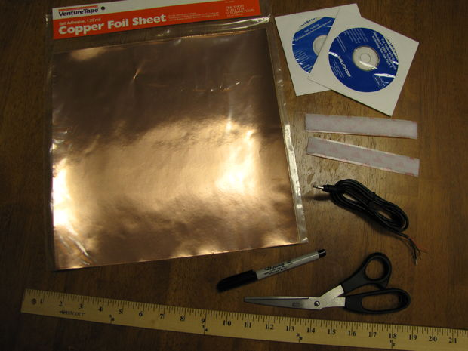

Materials Needed:

- Adhesive backed copper foil sheet. 5"x10".
- Adhesive backed Velcro strip. 6" of each side.
(I used 3/4", but nearly any width should work. Foam mounting squares will also work.)
- 3.5mm mono cable with male jack.
(Buy a 3.5mm mono extension cable, cut it in half, and use the male end for this, and the female end to make a No-Solder Battery Interrupter.)
- CDs. 2.
(Old software, AOL trials, blanks, whatever you have laying around.)

Tools:
- Scissors
- Ruler
- Sharpie (or other fine point marker)

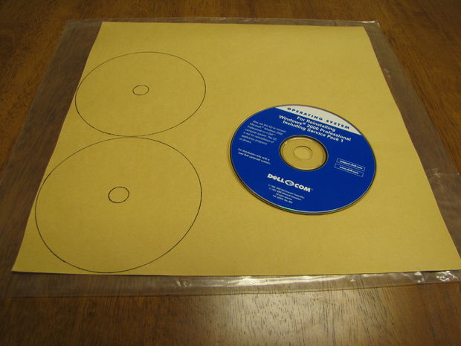
Step 2: Trace CDs Onto Foil Sheet

Use the Sharpie to trace two CDs onto the foil sheet. Flipping the sheet over and tracing onto the backing will help to avoid smearing ink on the copper itself.

(Place the CDs close to the edge, to preserve left over foil for use in more CD Switches or No-Solder Battery Interrupters.)

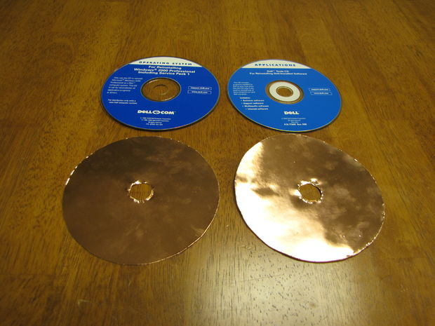
Step 3: Cut Out Foil Pieces

Use the scissors to cut out two CD-shaped pieces of foil. Cut slightly inside the lines, so that the pieces are slightly smalled than the CDs, and will not overlap their edges.

(Cutting out the center circles is optional, and will not affect the function of the switch.)

Step 4: Apply Foil To CDs

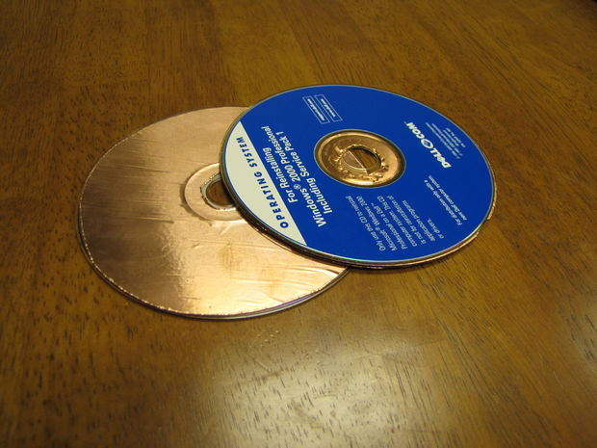
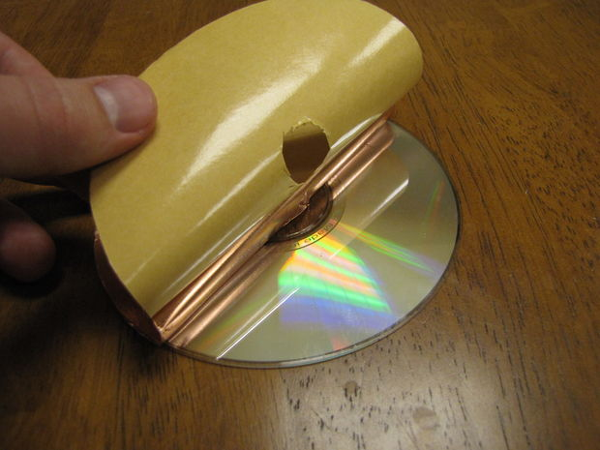

Peel the backing from one CD-shaped foil piece and attach it to one of the CDs. Repeat for the second piece of foil, attaching it to the second CD. Attach the foil to the bottom, label free side of the CDs, or the labels may peel off and destroy the switch.

The result will be two foil lined CDs.

(It helps to peel only a small portion of the backing, stick it to a CD, and then slowly peel off the rest of the backing as you affix the foil. This will also help to avoid causing bubbles under the foil.)

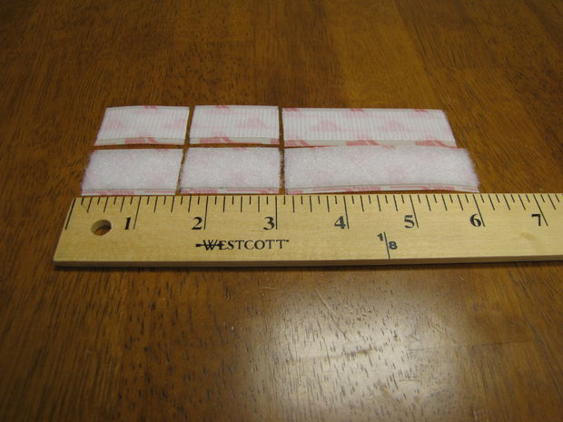
Step 5: Measure And Cut Velcro
Using the ruler and scissors, measure and cut the Velcro into pieces of 1.5", 1.5", and 3".

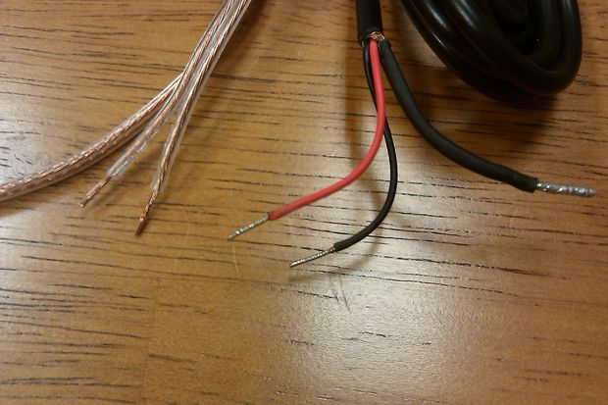
Step 6: Find Two Main Wires

Find the two main wires in the center of your cable. Some will only have two wires, while some will have a third wire, comprised of the strands that run through the outer insulator of the wire. If you cut and stripped the cable yourself, the outer insulator strands may be splayed out. If these are in the way, twist them together, fold them back, and tape them to the cable with electrical tape.

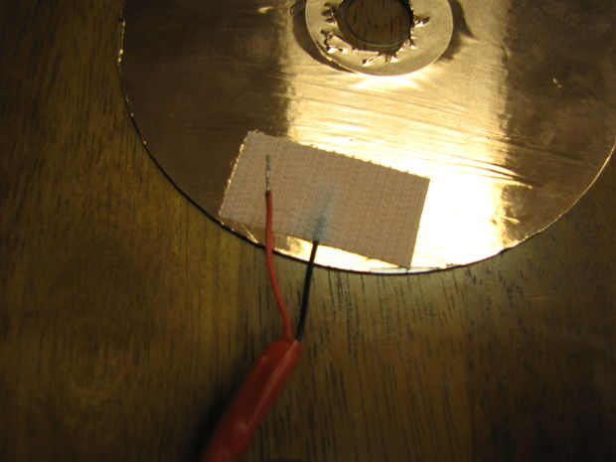
Step 7: Attach First Wire To CD

Using one of the 1.5" pieces of Velcro (hook or loop doesn't matter), attach the tip of one of the main wires to the outer edge of the copper side of the first CD. Make sure that the bare wire makes solid contact with the copper, and that the Velcro overlaps some of the wire's plastic insulation. Press hard and make a firm connection.

Step 8: Repeat With Second Wire And CD

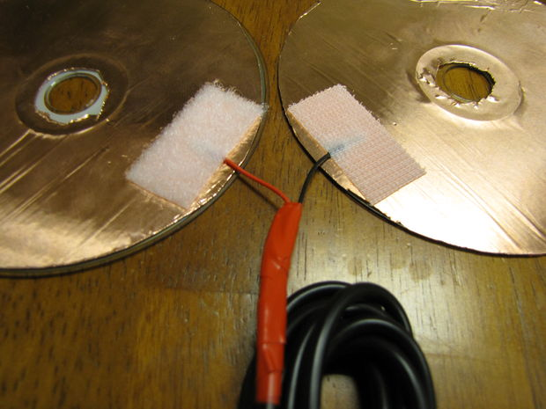
Repeat the previous step, attaching the second main wire to the copper side of the second CD. Use the opposite side (hooks or loops) of the same 1.5" piece of Velcro. Again, make sure that the bare wire makes solid contact with the copper, and that the Velcro overlaps some of the wire's plastic insulation.

(Note that the two pieces of Velcro line up, so that they will stick to each other when the CDs are pressed together.)

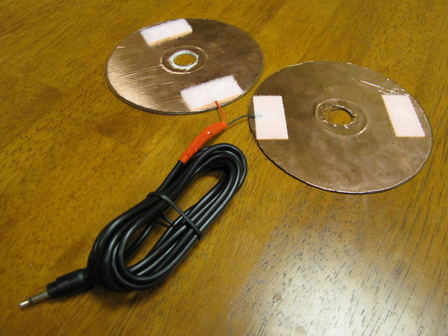
Step 9: Apply Velcro To Other End Of CDs

Apply the other pair of 1.5" pieces of Velcro (one hooks, one loops) to the opposite edges of the CDs, as shown in the image.

(Once again, note that these pieces of Velcro line up so that they will stick together when the CDs are pressed together.)

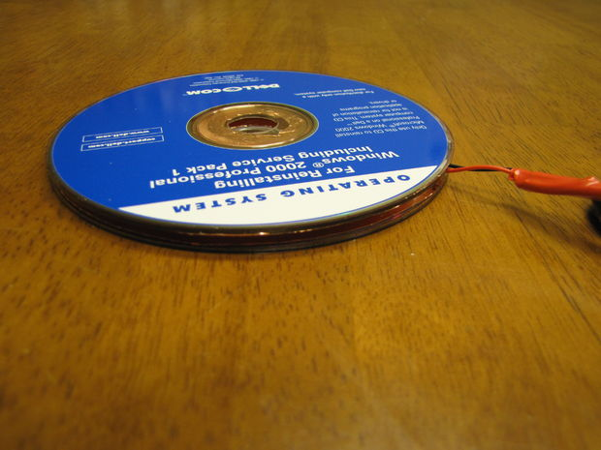
Step 10: Press Two CDs Together

Press the two CDs together, so that the Velcro lines up and sticks together, and the two wires line up at the edge of the CDs.

Step 11: Apply Velcro To One Side Of Switch For Mounting
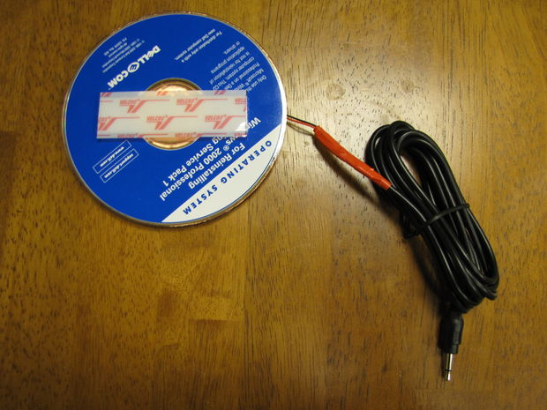
Stick the pair of 3" pieces of Velcro (hooks and loops) together, and attach them to one side of the CD switch, as shown in the image.

This Velcro will be used for mounting the switch. Peel the backing from the outer piece of Velcro and press it onto a solid surface to mount it. Simply peel apart the Velcro to remove the switch.

(Use more Velcro to create mounting points on multiple surfaces, and move the switch between them freely.)

Step 12: Test Your CD Switch
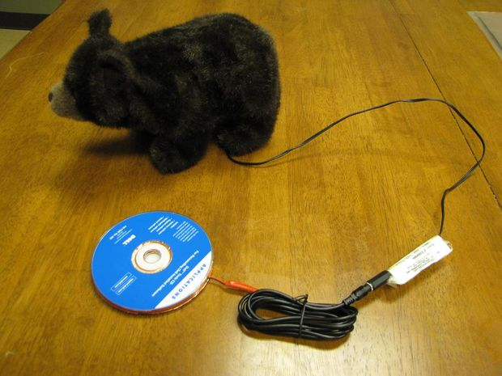
Test your new CD switch by plugging it into a switch adapted toy or device (anything controlled by a 3.5mm switch jack) and pressing the two CDs together. When the two pieces of copper foil touch, the circuit is completed, allowing current to flow from one wire to the other.

Now experiment! A switch is just a way of connecting two wires. Find other ways to touch two wires together and complete a circuit. Use some of the scrap pieces of foil from this project, along with tape, hot glue, super glue, solder, or whatever you have on hand. You don't even have to use foil if you can find a way for the tips of the wires to touch directly.

- The fingertips of a glove?
- The end of a clothespin?
- Something spring loaded that holds the wire apart or together?
- Be creative!

