No Solder Battery Interrupter

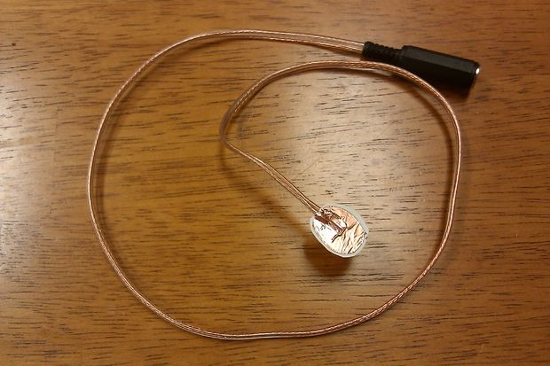

Materials needed:
- Adhesive backed copper foil sheet. Two 1"x1" pieces.
(Possibly the scraps from making a CD Switch. The kind with a black backing makes this easier.)
- Business card or small piece of poster board. One 1"x1" piece.
- 3.5mm mono cable with female jack.
(Buy a 3.5mm mono extension cable, cut it in half, and use the female end for this, and the male end to make a CD Switch.)
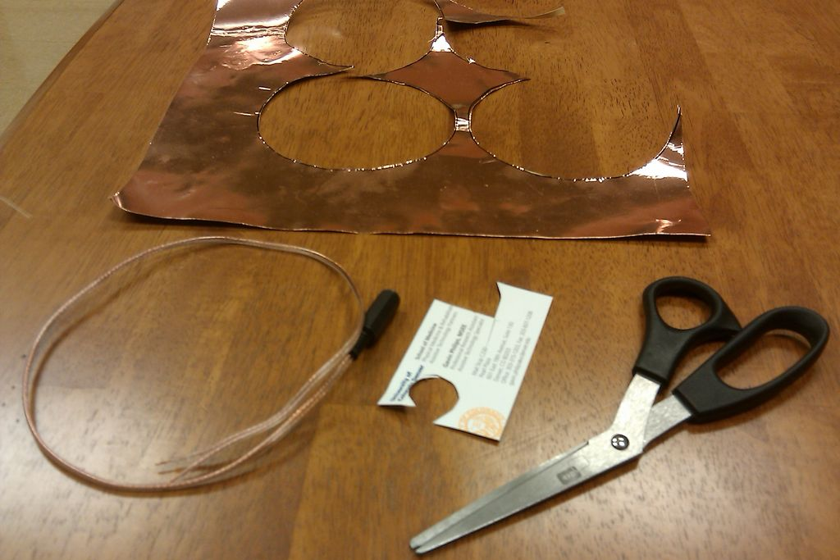

Tools:
- Scissors

Use the scissors to cut two circles of foil, approximately 1" in diameter, or the size of a quarter. (This can be trimmed down later to fit smaller batteries.)

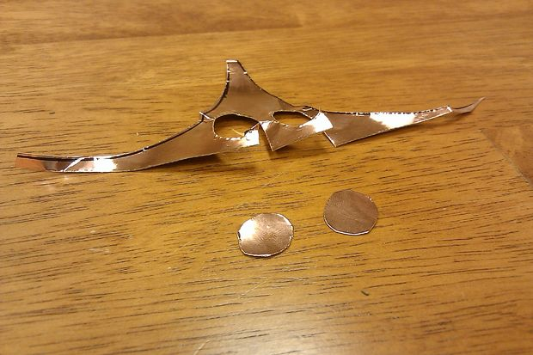

Peel the backing from one of the foil circles, and use the edge of the scissors to scrap away a small patch of adhesive in the center. Using a foil sheet with a black backing allows you to more easily what has been scraped clear.
(It helps to use the backing as a tool for handling the sticky circle of foil.)

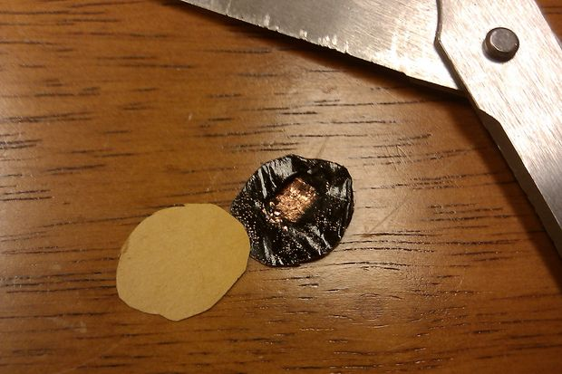

Find the two main wires in the center of your cable. Some will only have two wires, while some will have a third wire, comprised of the strands that run through the outer insulator of the wire. If you cut and stripped the cable yourself, the outer insulator strands may be splayed out. If these are in the way, twist them together, fold them back, and tape them to the cable with electrical tape.

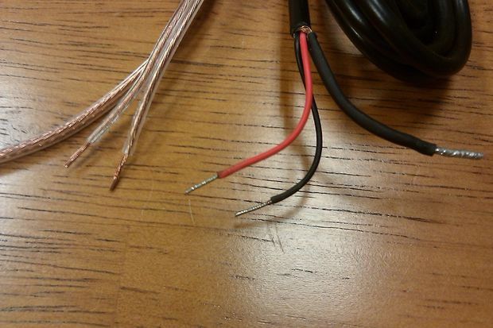

Place one of the two main wires on each side of the business card (or poster board). Be sure to leave a small amount of the plastic insulation of the wire overlapping the card.

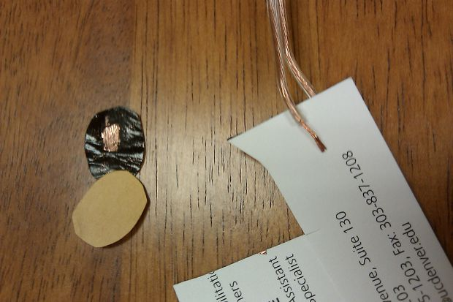

Press the circle of foil down on top of the wire, sticking it firmly to the card. Make sure that the bare, scraped patch touches the bare wire, and that some of the wire's plastic insulation is stuck between as well.

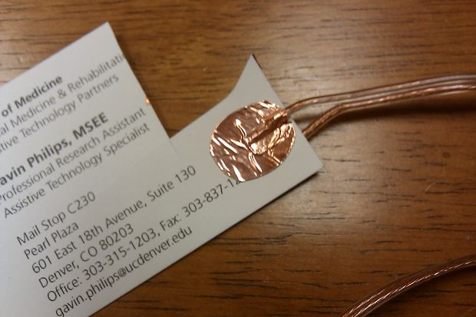

Flip the card over and repeat steps 3-6 for the other side. Peel the backing from the other circle of foil, scape off a small patch of adhesive, and use the circle to attach the second main wire to the opposite side of the card. Again, make sure that the bare patch of foil touches the bare wire, and that some of the wire's plastic insulation overlaps.

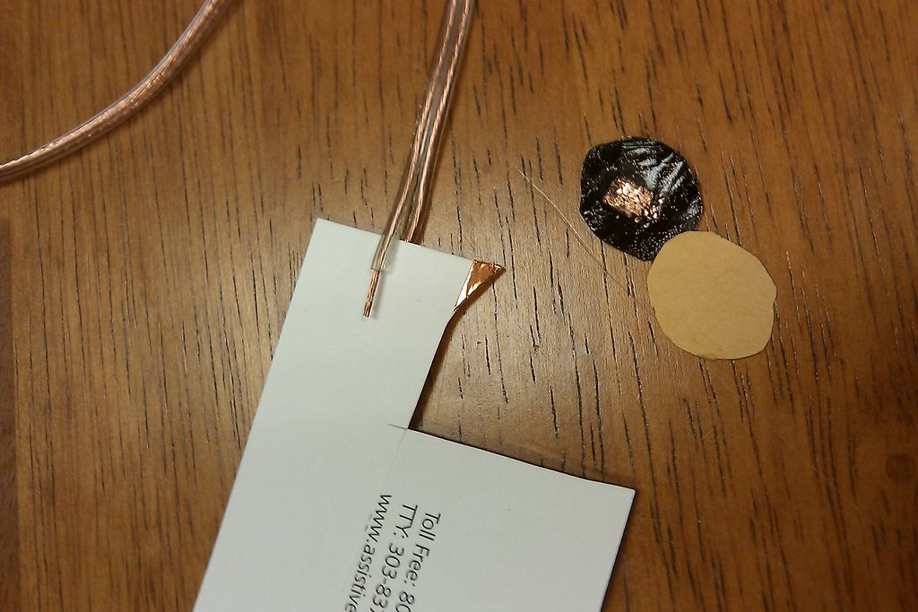

Use the scissors to cut around the outside of the foil, leaving a small amount of the card exposed around the edge. This will help to avoid short circuits as the battery interrupter is installed and used.
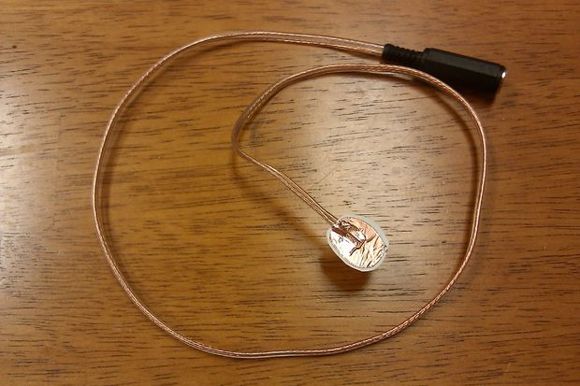

If you like, you can wrap electrical tape around the wires at the edge of the card, to hold them together and make the battery interrupter slightly more durable.
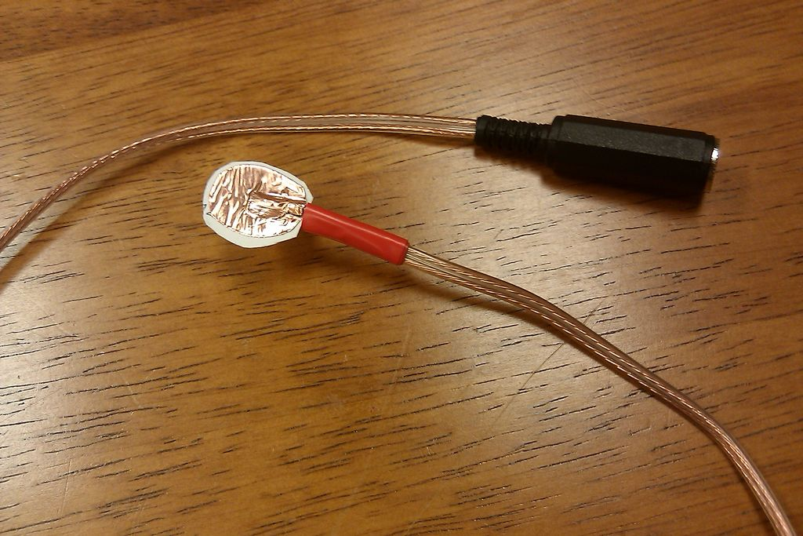

Now that you have a completed no-solder battery interrupter, test it with a toy or device. Slide the foil lined card between the batteries of the toy, separating them entirely. It may be necessary to pull the batteries apart, or remove them and press them back into place with the card between them.
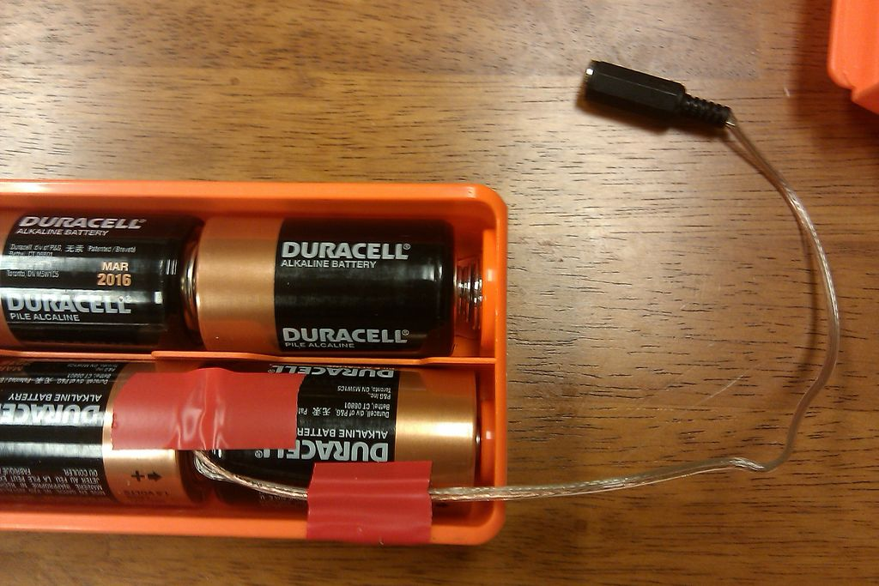
It may be necessary to file a small notch into the battery compartment of the toy, so that the wire can hang outside of the toy. You can also add more tape to hold the interrupter securely in place.
Plug any basic switch into the 3.5mm jack, turn on the toy's main control switch, and strap down the trigger if using a toy like this Nerf gun. There is animpressive variety of ability switches available, and you can make your own, like a CD Switch.
Activate the switch and enjoy!

