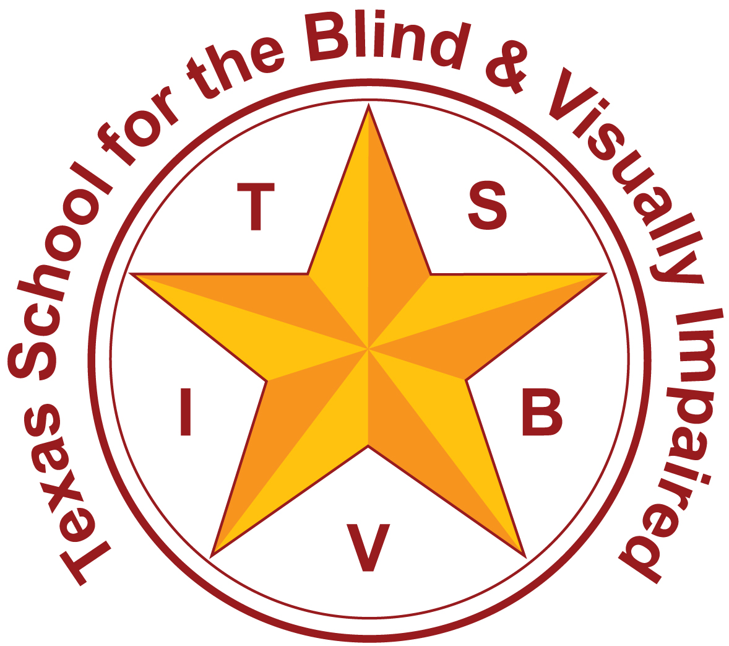
Texas School for the Blind and Visually Impaired
Outreach Programs
www.tsbvi.edu | 512-454-8631| 1100 W. 45th St. | Austin, TX 78756

Customized Employment We Can Do It!
TAER Conference
March 30th 2017

Presented by:
Texas School for the Blind & Visually Impaired Outreach Programs

Lynne McAlister Eva Thompson-Lavigne
VI Educational Specialist Transition Specialist
lynnemcalister@tsbvi.edu evalavigne@tsbvi.edu
512 206-9250 512 206-9271

What Would You Say Would Make a Good Life?
Life activities that are:
- Purposeful
- Meaningful
- Enjoyable

Everyone strives for a good quality life.
- The details of what makes “quality life” is different for each of us, and each of our children.
- These details may not be clear for some young people who have sensory impairments with additional disabilities, but we should be working to identify them.

Gifts and Possibilities Denise Bissonnette
- Every person is born with gifts to give.
- Not everyone’s gifts are obvious.
- For those individual’s whose gifts are not so obvious, it is our job to help them uncover their skills and abilities and help them see that they too have gifts.

Customized Employment
An Individualized Approach to Employment-one person at a time...one employer at a time.

Workforce Innovation Opportunity Act (WIOA)

Customized Employment Definition:
competitive integrated employment, for an individual with a significant disability, that is based on an individualized determination of the strengths, needs, and interests of the individual with a significant disability”, “designed to meet the specific abilities of the individual with a significant disability and the business needs of the employer,” and “carried out through flexible strategies.” As a result, customized employment is now among the available services from public Vocational Rehabilitation nationally.

A Parent Perspective (video clip)
Customized Employment
- Matches strengths, conditions and interests of the job seeker to identified business needs of an employer.
- Job carving, task reassignment, job sharing, self-employment
- It starts with discovery.

Answering questions about the future can be done through discovery
- Opportunities to try activity routines/work experiences in meaningful contexts along with guided questions lead students and those who know them to discover interests, preferences, and abilities.
- These preferred interests and activities lead toward individualized goals for the future.

Treasure Questions Discovering Interests
- What are some of the greatest sources of joy in your life?
- What are personal qualities you are proud to have?
- When do you find you are in your element?
- What inspires you?
- What do you often get complimented on?
- If you could do or be anything in the world what would it be? (Denise Bissonnette, Diversity World)

For each interest or meaningful experiences ask:
• How could it be a job?
• How could it be a business?
• How could it help in some place that needs volunteers?
• How could it bring you together with neighbors or others in the community?
• Could you do it for fun?
• Could it help you manage your home?
• Could it help you care for yourself?

Case Studies: Personal Stories of Transition and Adult Life
Trey, 17 years old.
Things Trey likes
- Animals and animal care!
- Golden Stirrup Rodeo Show

Things Trey likes
- Animals and animal care!
- Trey likes to move and exercise: activities such as walking, carrying, throwing, and pushing.
- Trey with a bowling ball.
- Trey on the Treadmill. (video clip)
- Throwing weighted balls

Are there other life activities these interests could lead toward?
- How could it be a job?
- How could it be a business?
- How could it help as a community service or in a place that needs volunteers?
- How could it bring you together with neighbors or others in the community?
- Could you do it for fun?
- Could it help you manage your home?
- Could it help you care for yourself?

Trey likes to move and exercise:
- activities such as walking, carrying, throwing, and pushing.
- At school, Trey started routines that he understands and enjoys surrounding collecting and sorting recyclable materials.
- He particularly enjoys pushing and unloading carts.

Trey’s recycling routine at school (video clip)
For this activity:
- How could it be a job?
- How could it be a business?
- How could it help as a community service or in a place that needs volunteers?
- How could it bring you together with friends, neighbors, or others in the community?
- Could you do it for fun?
- Could it help you manage your home?
- Could it help you care for yourself?

Trey’s small hometown has a recycling center, but no other convenient collection points.
- So Trey started convenient collection stations at two locations he knows well and likes: his church and barbershop.
(Trey also loves his haircuts.)

Barber shop! (video clip)
Collection site at his church.
- He collects, sorts, and delivers the items to the Recycling Center as a community service. He also receives compensation for some of the materials. Trey completes this job with the assistance of an intervener.

Future Goals: statement from Trey’s mom
I want to thank TSBVI and TWC/DARS for helping our family find something that Trey is not forced to do, but loves to do--that makes him feel and know that he is accomplishing something, and that makes him feel whole and complete. So when Trey is an adult and no longer has school, our goals are to already have something in place to stay active, keeping his sense of fulfillment, and to know that all things are possible. Just because you have a disability that does not mean there are not possibilities.

Tyrell, 19 years old.

Things Tyrell likes (Discovery)
- Sports-track
- Drawing
- Video games
- Helping people
- Working with kids with disabilities
- Being a mentor/role model
- Sharing his positive attitude
- Demonstrating a hard work ethic
- To be active-places to go/people to see/meaningful things to do.

For each interest or meaningful experiences ask:
• How could it be a job?
• How could it be a business?
• How could it help in some place that needs volunteers?
• How could it bring you together with neighbors or others in the community?
• Could you do it for fun?
• Could it help you manage your home?
• Could it help you care for yourself?

Tyrell’s TWC Caseworker (video clip)
Discovery School Based Work Activities (video clip)
Consider your student’s interests, abilities, and preferred activities:
- How could it be a job?
- How could it be a business?
- How could it help in some place that needs volunteers to do a community service?
- How could it bring you together with neighbors or others in the community?
- Could you do it for fun?
- Could it help you manage your home?
- Could it help you care for yourself?

Mr. Carter Teacher Perspective (video clip)
Tyrell’s Future
- Is working at BV Rehab and getting paid through Pre-Employment Training Funds
- Has applied for the PATHS program at Texas A&M
- Is a person of interest for a grant being written that will provide a job to clean and repair durable medical equipment for the state Independent Living Center.

Dre, 20 years-old
What Dre Likes (Discovery)
- Cooking
- Sports
- Working with people
- To be on time
- Following through and completing tasks-contributing
- Being around people
- Helping people

Are there other life activities these interests could lead toward?
- How could it be a job?
- How could it be a business?
- How could it help as a community service or in a place that needs volunteers?
- How could it bring you together with neighbors or others in the community?
- Could you do it for fun?
- Could it help you manage your home?
- Could it help you care for yourself?

TSBVI Cafeteria (pictures of Dre working in TSBVI school cafeteria)
Dre’s Customized Experience (video clip)
School District Perspective (video clip)
“You can put ability in dis-ability or you can make them disabled. What their ability is going to be is the way you perceive it.” (Andrew’s mom-Maria Hamilton from the Department of Labor Customized Employment video)

Texas School for the Blind & Visually Impaired
Outreach Programs
Figure 1 TSBVI logo.

