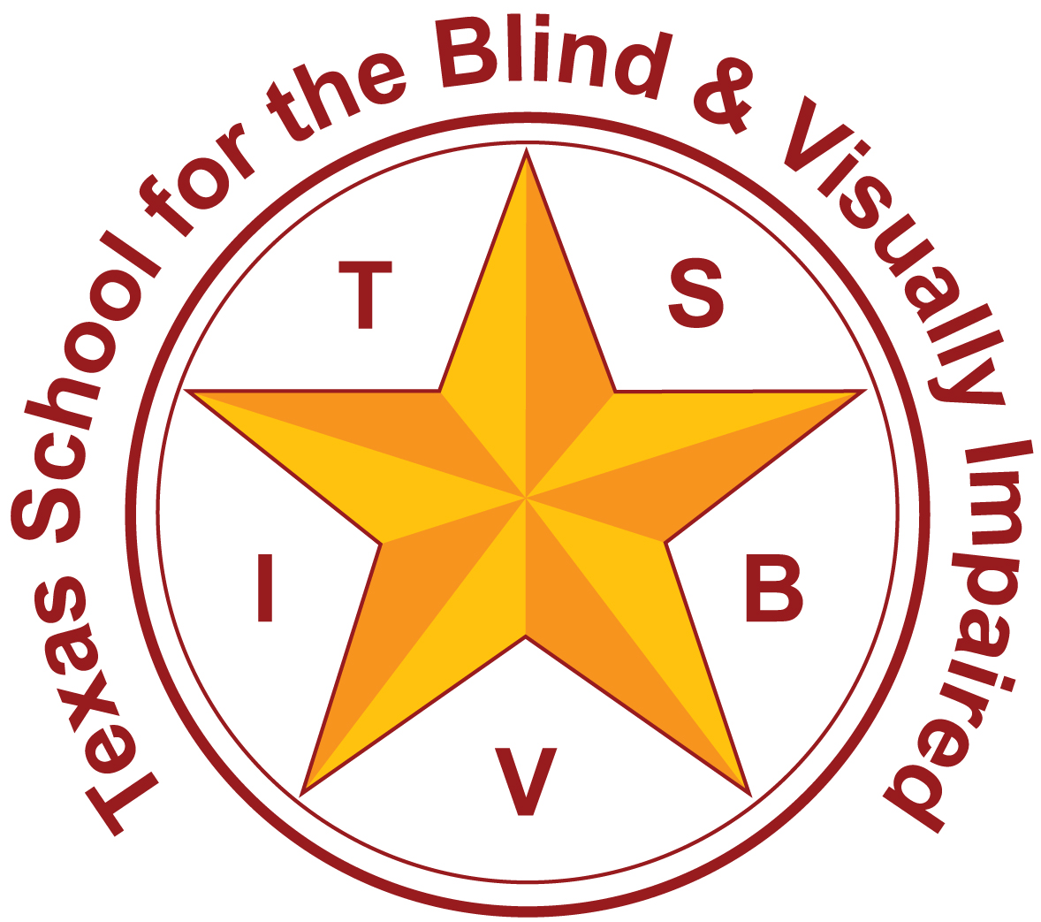
Texas School for the Blind and Visually Impaired
Outreach Programs
www.tsbvi.edu | 512-454-8631| 1100 W. 45th St. | Austin, TX 78756

How Refreshable Braille Displays Affect Computer Skills

Presented by
Sharon Nichols, Outreach Technology Consultant
March 31, 2017
nicholss@tsbvi.edu

Tools to Access the Curriculum
- Perkins braille writer
- Braille graph paper for math
- Tactile compass
- Cane
- Braille maps (tactile graphics)
- Laptop
- Braille note taker
- Daisy player

Braille in the Educational Toolbox
- No one-size-fits-all
- Every task
- Language Arts through Geography

What is a Braille Display?
Braille displays are hardware that enable users to read in Braille the text displayed on the computer screen. Using this device, blind people can navigate through the computer’s desktop, create and edit documents, and browse the Internet. A Braille display can also be called a Braille terminal.
What Is a Braille Display And How It Is Used. (n.d.). Retrieved March 21, 2017, from http://evengrounds.com/blog/what-is-a-braille-display
Why Consider a Braille Display?
- Student’s native writing code
- Literacy (difference between listening and reading)
- Editing
- Student can begin gathering own digital materials
- Opportunity to write braille in different environment

Reinforce Learning
- Allows for multimodal feedback with a screen reader
- Allows student to listen with a text-to-speech voice and at the same time read it on the display
- Gives the student more feedback and reassurance that what they’re hearing or writing is correctly written in Braille.

Accessibility and Efficiency
- A variety of tools enables an efficient way for a blind student to get the information as quickly and as efficiently as possible.
- Braille is a traditional format for reading

Pros and Cons

Pros
- More braille
- Independence
- Braille entry
- Silent reading
- Student can access digital materials

Cons
- Student resistance
- Technology
- Inaccessible educational materials
- Braille display settings
- Price and convenience

Demonstration and Discussion

Texas School for the Blind & Visually Impaired
Outreach Programs
Figure 3 TSBVI logo.

