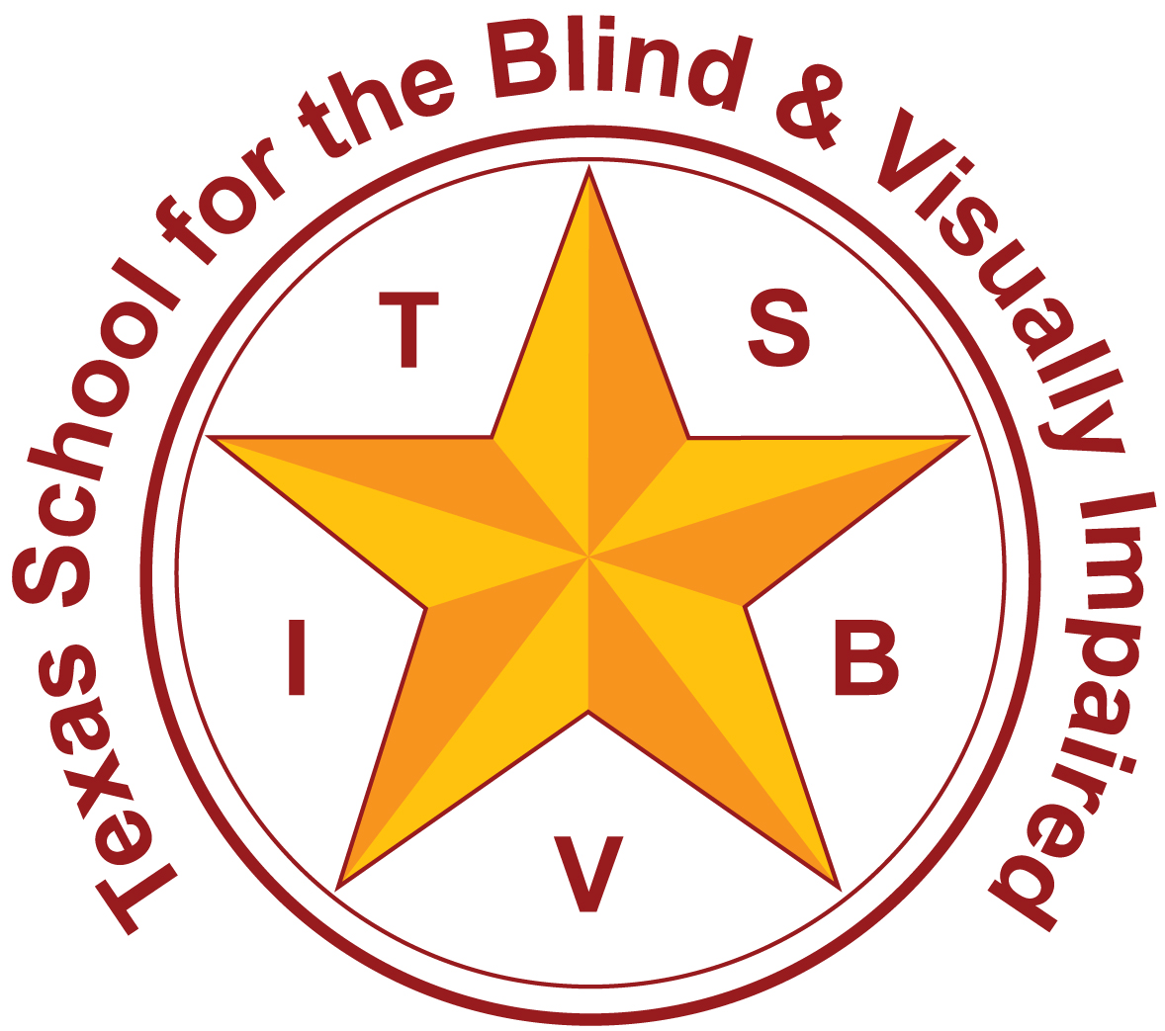
Texas School for the Blind and Visually Impaired
Outreach Programs
www.tsbvi.edu | 512-454-8631| 1100 W. 45th St. | Austin, TX 78756

How Technology Can Enhance Spatial Cognition

TAER Annual Conference
March, 2017

Chris Tabb
Statewide Orientation and Mobility Consultant
tabbc@tsbvi.edu

Developed for
Texas School for the Blind & Visually Impaired
Outreach Programs
Figure 1: The Texas School for the Blind and Visually Impaired logo

Spatial Cognition 101
What is “spatial cognition”?

Developing Spatial Cognition
How is spatial cognition developed, both in childhood and as an adult?

Developing Spatial Cognition
Can Purposeful Movement exist in the real world and an imaginary world?

Spatial Cognition from Games
- Twister (tactile)
- Marco Polo
- Audio Games
- Research into Navigating Virtual Environment Games

Developing Spatial Cognition
Spatial knowledge and language connection

Extending Spatial Cognition
How do we explore our worlds and in which ways do we use technology?

Spatial Cognition via Signals
Comparing technologies of GPS and Beacons.
- Location or Proximity?
- Indoors or Outdoors?

Beacons
Figure 2: Several beacons in a variety of colors; the beacons resemble egg size stones covered with a silicone skin.

Beacon Technology
- Relatively inexpensive
- Requires connection to a smartphone to access beacon information
- “ClickAndGo Maps” and “RightHear”

Let’s Talk Through It…
Siri, OK Google, and Alexa

Are We Teaching the Concepts Learners Need?
- Inches, Feet, Meters, and Yards
- Latitude, Longitude, and Landmarks
- Hours, Minutes, Seconds to Decimal Format Conversions
- Clock-Face Orientation

GPS Apps for Varied Applications
- BlindSquare
- APH Nearby Explorer
- Seeing Eye GPS
- Ariadne

Figure 3: Two screen shots of BlindSquare app. The first is the home screen with a list of categories to search for. The second is the tools menu with options such as Look Around, Your Location, Around Me, Beacon Radar, etc.

Figure 4: Two screen shots of BlindSquare app. The first is the settings page, which includes Directions Style. The second shot is of the Directions Style options list, including: Clock Face, Proportional, Degree, and Cardinal directions.

Figure 5: Two screen shots of BlindSquare app. The first is the Edit Place screen that includes the option to open the Edit Coordinates page. The second screen shot is of the Edit Coordinates screen with fields for Latitude and Longitude expressed in decimal format.

Figure 6: Two screen shots of APH Nearby Explorer app on iOS. The first screen shows search page results and the context menu with options that include: Save to Favorites, Turn-By-Turn Guidance, List Directions, Set As Watch, Virtual Go To, etc. The second screen shot is of the Virtual
Exploration page showing the options at the bottom to virtually travel North, South, East, and West from the present virtual location.

Figure 7: Two screen shots of Seeing Eye GPS app. The first screen is of the Route Creation page with options listed for: Home, Points of Interest, Street Address, Contact Address, and History. The second screen shot is a Location page showing the nearby street address, the present direction the phone is facing, a detailed description of the intersection ahead; this includes the shape of the intersection as well as the street name along with clock face location of each street. Also on the location page is a list of the nearest Points of Interest.

Figure 8: Two screen shots of Ariadne app. The first is a screen shot of the Favorites entry page showing fields for Description, address, latitude and longitude, and options for alerts related to the favorite. The second shot is of the Favorites Manager with option for alert styles, orientation style preference, etc.

Figure 9: A screen shot of the built in compass app on iOS phones. It displays the compass circle with a north indicator, the present degree location, latitude and longitude in Hours, Minutes, Seconds format, and the present elevation.

Incidental Learning with Technology
What About Technology for Learners Who Have Tech-Phobia, or Young Children Just Beginning to Learn Technology?

Accessible GPS Apps
- Provide spoken street name prompts
- Easily installed on parent’s smart phone so young learner can listen and learn about community street connections

Trekker Breeze+
Figure 10: Trekker Breeze Plus, has nine buttons with three at the top, three in the middle, and three at the bottom. In the middle of the top row is a large round button.

Trekker Breeze+
- Easier for some when first starting out, no touch screen challenge
- One large button for “Where Am I”
- Street names announced on bus or in car with no button press required

Is It Virtual or Augmented Reality?
Look Around, Magic Wand, and Geobeam just to name a few…

Virtual Exploration and Navigation
- Options to explore maps of unfamiliar areas as one would do virtually with Google Maps Street View

Talking or Braille Compass
Figure 11: An talking compass next to a braille compass.

Tactile Maps and Models
- Can be created to any scale to match needs of learner and environment
- Sets such as APH’s Tactile Town
- Hi-Tech creation options
- Low-Tech creation options

Hi-Tech Tactile Maps
- 3-D Pen
- Fuser and Swell Paper
  - Tactile Image Enhancer (TIE)
  - Picture In A Flash (PIAF)
- Embosser from Word Document or QuickTac
- 3-D Printing

Accessible Measurement
- Rope with knots every yard
- Braille caliper
- Talking measuring tapes and measuring apps with VoiceOver

Auditory Distance Sense
- Auditory cues, clues, and landmarks
- Echolocation
- Auditory horizon

Haptics & Sensory Substitution
- Mini-Guide
- K-Sonar
- Apple Watch with Haptic Engine
- Lechal Shoe Inserts

Lechal
Figure 12: Shoe inserts showing bottom side with pocket where Lechal pods are located as well as the front and back of Lechal pods, which are small and low rectangular boxes about the size of a matchbox.

Resources
Figure 13: QR or Quick Response code for using an app to scan the code and launch the web site listed above.

Texas School for the Blind & Visually Impaired Outreach Programs

How Technology Can Enhance Spatial Cognition

TAER Annual Conference
March, 2017

Chris Tabb, Statewide Orientation and Mobility Consultant

tabbc@tsbvi.edu

Figure 14: IDEAs That Work logo and OSEP disclaimer

Figure 15: The Texas School for the Blind and Visually Impaired logo

