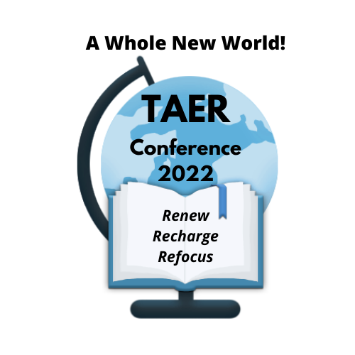
TAER Conference 2022
Agenda at a Glance

Wednesday March 30, 2022
6:00pm – 8:00pm Registration open

Thursday, March 31, 2022
8:00am – 4:00pm Registration
9:00am – 11:00am Pre-Conference
11:00am – 1:00pm Lunch on your own
12:00pm – 5:00pm Exhibits Open
1:00pm – 2:15pm Welcome and Keynote Address
2:15pm – 2:30pm Announcements & Board Nominations
2:45pm – 4:00pm Session 1
4:00pm – 4:15pm Break
4:15pm – 5:30pm Session 2
6:00pm – 8:00pm Presidents’ Reception

Friday, April 1, 2022
8:00am – 4:00pm Registration
8:00am – 4:00pm Exhibits Open
8:00am – 6:00pm Electronic Voting for 2022-2023 Board Members
9:00am – 10:15pm Session 3
10:15am –10:45pm Exhibit Visiting Time/Break
10:45am –12:00pm Session 4
12:15pm – 2:00pm Awards Luncheon
2:15pm – 3:30pm Session 5
3:30pm – 3:45pm Break
3:45pm – 5:00pm Session 6
5:00pm Silent Auction closes
5:00pm – 5:30pm Silent Auction Winners Announced
5:30pm – 6:30pm Session 7 - Division Meetings

Saturday, April 2, 2022

8:00am – 9:30am Breakfast, TAER Business Meeting, & Door Prizes (need to be present to receive door prize)
10:00am – 11:15am Session 8
11:30am– 12:45pm Session 9

